OOSE Lab Week 2

Contents

1 Create a simple use case diagram 1

Week 2

# Create a simple use case diagram

Create a simple use case diagram using visual paradigm (or other tool).

Choose a domain of interest to you.

Experiment with the tool to see what it can do.

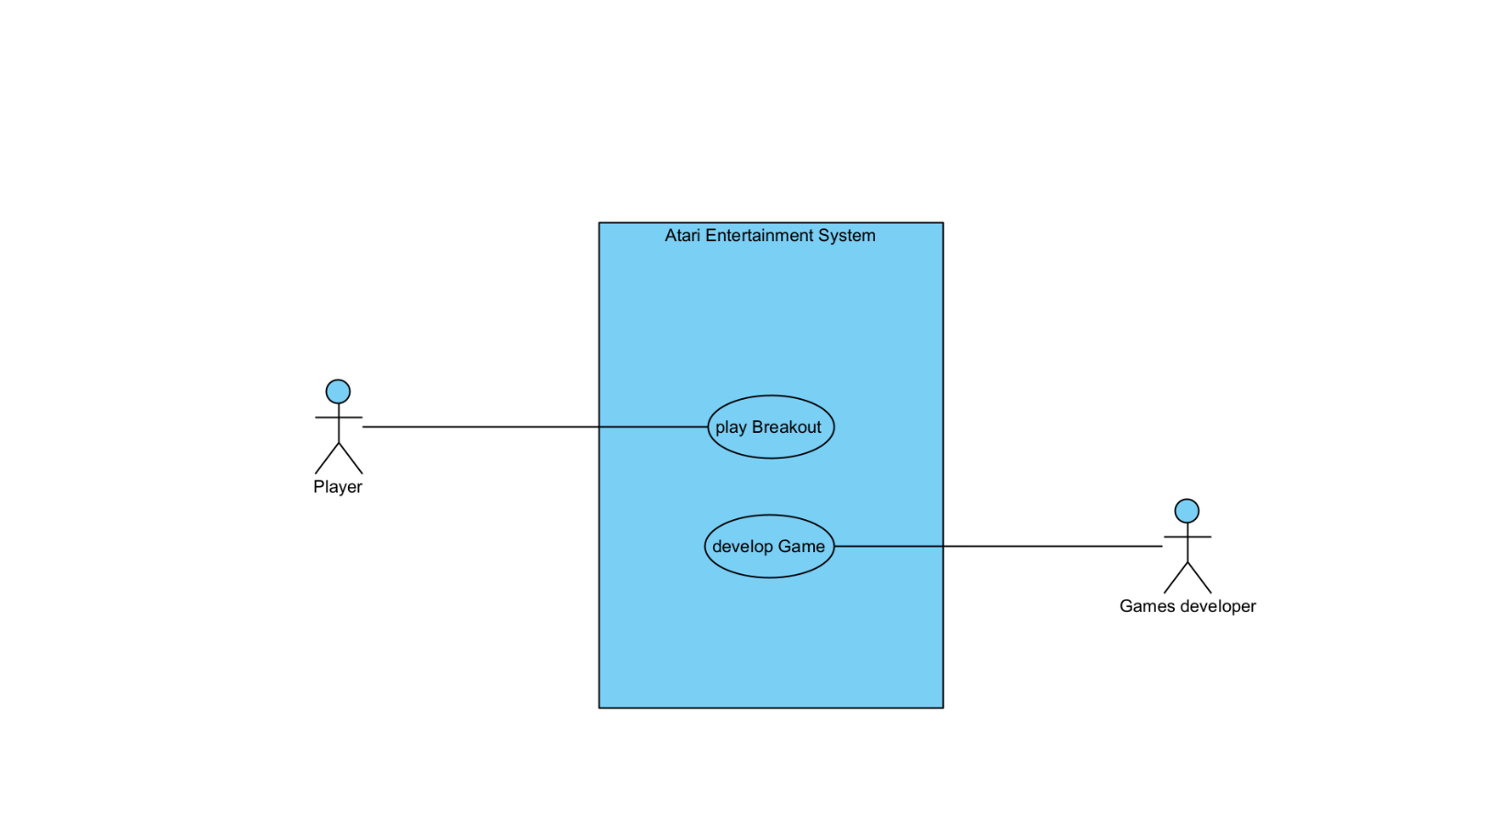Atari Entertainment Video Game system Use Case Diagram